OS Upgrades
-What happens when one of the nodes go down? If the node came back online immediately, then the kubectl process starts and the pods come back online. However, if the node was down for more than 5 minutes, then the pods are terminated from that node. Well, kubernetes considers them as dead. If the PODs where part of a replicaset then they are recreated on other nodes.
-The time it waits for a pod to come back online is known as the --pod-eviction-timeout and is set on the controller manager with a default value of five minutes. So whenever a node goes offline, the master node waits for upto 5 minutes before considering the node dead.
-When the node comes back on line after the pod eviction timeout it comes up blank without any pods scheduled on it.
-If you have maintenance tasks to be performed on a node, if you know that the workloads running on the Node have other replicas and if it's okay that they go down for a short period of time. And if you're sure the node will come back online within five minutes you can make a quick upgrade and reboot.
-However, you do not for sure know if a node is going to be back online in five minutes, there is a safer way to do it. You can purposefully drain the node of all the workloads so that the workloads are moved to other nodes in the cluster. Well technically they are not moved. When you drain the node the pods are gracefully terminated from the node that they're on and recreated on another. The node is also cordoned or marked as unschedulable. Meaning no pods can be scheduled on this node until you specifically remove the restriction. Now that the pods are safe on the others nodes, you can reboot the first node. When it comes back online it is still unschedulable. You then need to uncordon it, so that pods can be scheduled on it again.
-Remember the pods that were moved to the other nodes, don’t automatically fall back. If any of those pods where deleted or if new pods were created in the cluster, then they would be created on this node.
-Cordon command simply marks a node unschedulable. Unlike drain it does not terminate or move the pods on an existing node. It simply makes sure that new pods are not scheduled on that node.
-Drain node: kubectl drain node-1
kubectl drain node-1 --ignore-daemonsets
kubectl drain node-1 --ignore-daemonsets --force
-Uncordon node: kubectl uncordon node-1
-Cordon node: kubectl cordon node-2

Kubernetes software versions
-‘kubectl get nodes’ command shows the Kubernetes version running on nodes.
-‘v1.11.3’ => MAJOR_VERSION.MINOR_VERSION.PATCH_VERSION
-https://github.com/kubernetes/kubernetes/releases
-https://kubernetes.io/docs/concepts/overview/kubernetes-api/
-https://github.com/kubernetes/community/blob/master/contributors/devel/sig-architecture/api-conventions.md
-https://github.com/kubernetes/community/blob/master/contributors/devel/sig-architecture/api_changes.md

-Cluster upgrade process
-It is not mandatory have the same version for all core control plane components kube-apiserver, controller-manager, kube-scheduler, kubelet, kube-proxy. Since the kube-apiserver is the primary component to which all other components talked to, none of the other components should ever be at a version higher than the kube-apiserver.
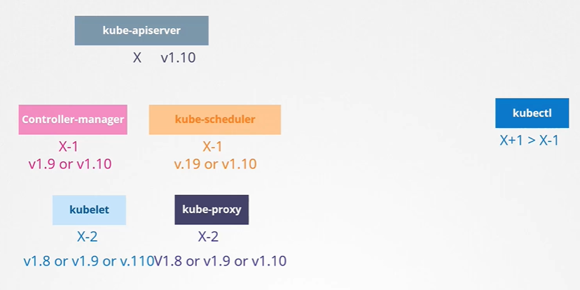
-When should you upgrade? At any time Kubernetes support only up to the recent three minor versions.
-How do we upgrade? Do we upgrade directly from 1.10 to 1.13 directly (in between we have 1.11, 1.12)? No. The recommended approach is to upgrade one minor version at a time.
-The upgrade process depends on how your cluster is setup.
- If your cluster is a managed Kubernetes cluster deployed on cloud service providers like Google. Google Kubernetes engine lets you upgrade your cluster easily with just a few clicks.
- If you deployed your cluster using tools like kubeadm then the tool can help you plan and upgrade the cluster.
kubeadm upgrade plan
kubeadm upgrade apply
- If you deployed your cluster from scrach then you manually upgrade the different components of the cluster yourself.
-Upgrade using kubeadm
- Upgrading a cluster involves two major steps: first upgrade your master nodes and then upgrade the worker nodes.
- While the master is being upgraded, the control plane components such as the API server, scheduler and controller managers go down briefly. The master going down does not mean your worker nodes and applications on the cluster are impacted, all workloads hosted on the worker nodes continue to serve users as normal.
- Since the Master is down all management functions are down. You cannot access the cluster using kube control or other kubernetes API. You cannot deploy new applications or delete or modify existing ones. The controller managers don't function either. If a pod fails, a new pod won't be automatically created. But as long as the nodes and the pods are up, your applications should be up and users will not be impacted.
- There are different strategies available to upgrade the worker nodes.
  - One is to upgrade all of them at once but then your ports are down and users are no longer able to access the applications. Once the upgrade is complete, the nodes are back up new pods are scheduled, and users can resume access. That's one strategy that requires downtime.
  - The second strategy is to upgrade one node at a time. We first upgrade the first node where the workloads move to the second and third node and users are so from there. Similarly, for rest of the nodes.
  - A third strategy would be to add new node to the cluster, nodes with newer software version. This is especially convenient if you're on a cloud environment where you can easily provision new nodes and decommission old ones. Nodes with the newer software version can be added to the cluster, move the workload over to the new and remove the old node until you finally have all new nodes with the new software version
  - kubeadm upgrade plan: Gives cluster version, kubeadm version, latest Kubernetes version, all control plan component version and their latest available version. Also tells that once we update control plan components, manually update kubelet to latest version on each version. Kubeadm doesnot install/update kubelet. Also give command to upgrade cluster. Update kubeadm tool before updating cluster. Kubeadm tool also follows same software version as Kubernetes.
    - Update kubeadm: apt-get upgrade -y kubeadm=1.12.0-00
      - Check kubeadm version: kubeadm version
    - Update cluster: kubeadm upgrade apply v1.12.0
    - Update kubelet on master nodes if we have kubelet on them:
      - Update kubelet: apt-get upgrade -y kubelet=1.12.0-00
        - OR apt install -y kubelet=1.12.0-00
      - Restart kubelet service: systemctl restart kubelet
    - Update kubelet on worker node (node-1):
      - Move pods to other nodes and cordon it: kubectl drain node-1 --ignore-daemonsets
      - Update kubeadm: apt-get upgrade -y kubeadm=1.12.0-00
        - OR kubeadm upgrade node
      - Upgrade kubelet: apt-get upgrade kubelet=1.12.0-00
      - Update node configuration for new kubelet version: kubeadm upgrade node config --kubelet-version v1.12.0
      - Restart kubelet service: systemctl restart kubelet
      - kubectl uncordon node-1
https://kubernetes.io/docs/reference/setup-tools/kubeadm/kubeadm-upgrade/

Backup and Restore Methods
-Backup candidates
- Resource configuration
  - definition files -> Store in source code repository like GitHub
  - created using imperative way (Using commands) -> This cannot be backed-up
- ETCD cluster
- Persistent Volumes
-Resource configuration can be backed-up using following ways:
- Query the kube-api server. Query the kube-api server using kubectl or by accessing the API server directly and save all resource configurations for all objects created on the cluster as a copy:
  - kubectl get all --all-namespaces -o yaml > all-deploy-services.yaml
- There are tools like ARK or now called Velero by Heptio that can help in taking backups of your Kubernetes cluster using the Kubernetes API.
-ETCD server
-The ETCD cluster stores information about the state of our cluster. So, information about the cluster itself, the nodes and every other resource created within the cluster are stored here. So instead of backing up resource as before, you may choose to back-up the ETCD server itself.
-ETCD cluster is hosted on the master nodes. While configuring ETCD we specified a location where all the data would be stored. The directory specified using --data-dir option, this directory can be configured to be backup by your backup tool.
-ETCD also comes with a built-in snapshot solution. You can take a snapshot of the ETCD database by using the etdctl utilities snapshot save command:
- Take snapshot: ETCDCTL_API=3 etcdctl snapshot save snapshot.db
- Check status of snapshot: ETCDCTL_API=3 etcdctl snapshot status snapshot.db
-To restore ETCD cluster from backup at later point of time
- Stop kube-apiserver: service kube-apiserver stop
- ETCDCTL_API=3 etcdctl snapshot restore snapshot.db --data-dir /var/lib/etcd-from-backup --initial-cluster master-1=https://192.168.5.11:2380, master-2=https://192.168.5.12:2380 --initial-cluster-token etcd-cluster-token --initial-advertise-peer-urls Error! Hyperlink reference not valid.
- systemctl daemon-reload
- service etcd restart
- service kube-apiserver start
-When ETCD restores from a backup, it initializes a new cluster configuration and configures the members of ETCD as new members to a new cluster. This is to prevent a new member from accidentally joining an existing cluster.
-With all the ETCD commands remember to specify the certificate files for authentication. Specify the endpoint to the ETCD cluster and the ca-certificate, the etcd-server certificate and the key.
- --endpoints=https://127.0.0.1:2379 --cacert=/etc/etcd/ca.crt --cert=/etc/etcd/etcd-server.crt --key=/etc/etcd/etcd-server.key

Working with ETCD
-etcdctl is a command line client for etcd
-To make use of etcdctl for tasks such as back up and restore, make sure that you set the ETCDCTL_API to 3.
- export ETCDCTL_API=3

Restore and backup section answers: https://github.com/mmumshad/kubernetes-the-hard-way/blob/master/practice-questions-answers/cluster-maintenance/backup-etcd/etcd-backup-and-restore.md

References
-https://kubernetes.io/docs/tasks/administer-cluster/configure-upgrade-etcd/#backing-up-an-etcd-cluster
-https://github.com/etcd-io/etcd/blob/master/Documentation/op-guide/recovery.md
-https://www.youtube.com/watch?v=qRPNuT080Hk

